MATHEMATICS TEAM CHALLENGE
2025

TEAM EVENT: Intermediate (Year 9 and Year 10) Time: 45 minutes
(Calculators are allowed) Total: 150 points
Please write answers on the answer sheet.

T1. (15 points)
What is the average of the following sum of one million consecutive positive integers?

$$1+2+3+4+…………+999998+999999+1000000$$

T2. (20 points)
A Futsal squad consists of 10 players. How many different starting teams of 5 players are possible?

T3. (10 points)
In the multiplication sum below, the five letters represent five different digits. Given that there is no ‘0’, what is the numerical value of MEATS?

$SEAM$
$×T$
$MEATS$

T4. (10 points)
Any natural number can be written as a sum of natural numbers. For example, 3 can be written as a sum in three different ways:
3=3
3=2+1
3=1+1+1

The number 4 can be written as a sum in five different ways:
4=4
4=3+1
4=2+2
4=2+1+1
4=1+1+1+1

How many ways can the number 6 be written as a sum?

T5. (20 points)
Three boys and four girls are randomly seated in row. What are the chances that the two children at both ends of the row will be boys?

T6. (15 points)
What is the area of the largest regular hexagon that can be inscribed inside a square with an area of 1m²?
Answer to two decimal places.

T7. (15 points) A new internet social network opened on January 1, 2025. The number of members in the network doubles every month. In how many months will the number of members increase from 1 to over fifty million for the first time.

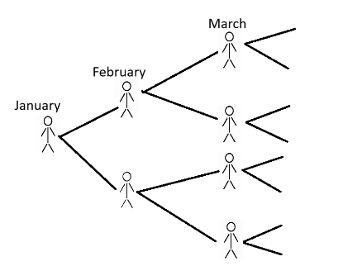

T8. (15 points)
How many factors does the product below contain? (Include 1 and p as factors)

$$p= 2^{3}×3^{3}×5^{3}×7^{3} ×{11}^{3}×{13}^{3}$$

T9. (15 points)
A farmer bought a hundred animals at a total cost of $1000. The price of sheep is $50 each, goats $10 each and chickens $0.5 each. How many goats did he buy, given he bought at least one of each animal?

T10. (15 points)
All of the possible 4-digit permutations of the digits 1, 2, 3 and 4 are arranged in ascending order. What is the probability that a permutation is divisible by 11?

School Name: ____________________________________ Team: ___________

2025 MATHEMATICS TEAM CHALLENGE

INTERMEDIATE (Year 9 and Year 10)

TEAM EVENT

ANSWER SHEET

Question | Answers | Points
T1. (15 points)
T2. (20 points)
T3. (10 points)
T4. (10 points)
T5. (20 points)
T6. (15 points)
T7. (15 points)
T8. (15 points)
T9. (15 points)
T10. (15 points)

Total /150

2025 MATHEMATICS TEAM CHALLENGE

INTERMEDIATE (Year 9 and Year 10)

TEAM EVENT

ANSWER SHEET

Question | Answers
T1. (15 points) | 500000.5
T2. (20 points) | 252
T3. (10 points) | 39784
T4. (10 points) | 11
T5. (20 points) | $$\frac{720}{5,040}= \frac{1}{7} or 0.142857…or 14.29\%$$
T6. (15 points) | 0.65m²
T7. (15 points) | 26 months
T8. (15 points) | 4096
T9. (15 points) | 1
T10. (15 points) | $\frac{8}{24} or \frac{1}{3}$or 33$\frac{1}{3}$ %

