2025 MATHEMATICS TEAM CHALLENGE

Primary Team Event

Time: 45 minutes Calculators Allowed Total Points: 100
----------------------------------------------------------------------------------------------------------------------------

T 1. (12 points)

The 2 x 2 grid below is worth 9 points and the 1 x 1 grid is worth 4 points.
= 4 points
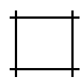
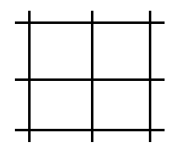
= 9 points

How many points is a 3 x 3 grid worth?

T 2. (8 points)

How many factors does 2025 have? Include 1 and 2025 as factors.

T 3. (6 points)

Stephen worked from 1:30PM until 3:20PM on his assignment. Jacob started 20 minutes after Stephen started and took one and a half times as long as Stephen took to finish the task.

When did Jacob finish?

T 4. (10 points)

In a class of boys and girls, $\frac{2}{3}$ of the boys passed a test and $\frac{1}{2}$ of the girls passed the test. What is the smallest possible number of students in the class, if the total number of students who passed the test was 14.

T 5. (8 points)

What are the values of x and y, if $x+y=18$ and $x$is greater than $y$?

$$\frac{1}{x}+\frac{1}{y}= \frac{1}{4}$$

T 6. (6 points)

The growth rate of human fingernails is 0.1mm/day. How long would a fingernail increase in length by, over a period of 100 million seconds?

T 7. (6 points)

A piece of paper 0.01mm thick is cut in half, and one piece is placed on the other to make a pile. Next, these are cut in half and all four pieces are placed in a pile. Next, these four pieces are cut in half and are placed in a pile and the process continues. How many cuts are needed until the pile first exceeds one centimetre in height?

T 8. (6 points)

Mrs Smith recorded the test scores for her class of 20 students. Overall, the average for the class was 80. Mrs Smith accidently recorded one of the test scores as 88 instead of 68.What was the correct class average?

T 9. (10 points)

The letters of the alphabet are assigned the numbers from 1 to 26. A = 1, B = 2, C = 3,…….Y = 25,

and Z = 26. SUM is a mathematical word which has a product value of 5187. (SUM = 19 x 21 x 13)

What is another mathematical word with four letters that has a product value of 630?

T 10. (8 points)

The digits 4, 5 and 1 are arranged to form all possible 3-digit numbers with no repeats. Which arrangement of numbers has the most factors? (For example, 145 has four factors: 1, 5, 29 and 145)

T 11. (10 points)

Find two values for X, such that the mean and the median for the five numbers X, 6, 4, 1 and 9 are equal.

T 12. (10 points)

Four triangular gardening plots form a square as shown below. Each plot contains one type of flower and there are four types of flowers to choose from. The four types of flowers include roses, dahlias, chrysanthemums and daises. One arrangement is shown below. How many arrangements are there in total?

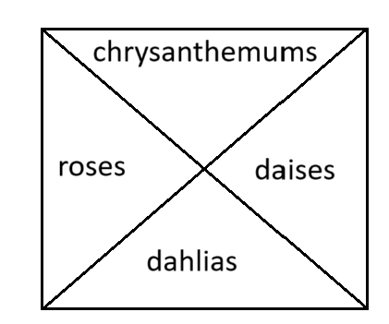

MATHEMATICS TEAM CHALLENGE (2025)

TEAMS CONTEST ANSWER SHEET

PRIMARY

All units to be included
Question | Points | Answer
T 1 | 12
T 2 | 8
T 3 | 6
T 4 | 10
T5 | 8
T6 | 6
T7 | 6
T8 | 6
T9 | 10
T10 | 8
T 11 | 10
T12 | 10
Total

School:___________________________________________________

Team 1: Team 2: Team 3:

MATHEMATICS TEAMS CHALLENGE (2025)

PRIMARY TEAMS CONTEST 2025

ANSWER SHEET

Question | Points | Answers
T 1 | 12 | 16 points
T 2 | 8 | 15
T 3 | 6 | 4:35pm
T 4 | 10 | 22
T5 | 8 | x = 12 and y = 6
T6 | 6 | 115.74mm or 11.57cm
T7 | 6 | 10 cuts
T8 | 6 | 79
T9 | 10 | CUBE
T10 | 8 | 154
T 11 | 10 | 0, 5 and 10  (10 points for any 2 correct)
T12 | 10 | 24

