2025 MATHEMATICS TEAM CHALLENGE
INTERMEDIATE SECONDARY (year 9 & 10)
RELAY CONTEST

Time: 1 hour
Calculators may be used
Each question is worth 5 points
Total of 100 points

R1 (5 points) (95 points remaining)
The number 1 is both the square and the cube of an integer. What is the next larger integer which is both the square and the cube of a positive integer?

R2 (5 points) (90 points remaining)
An odd number between 301 and 370 has three different digits. If the sum of the digits is five
times the tens digit, what is the number?

R3 (5 points) (85 points remaining)
One mouse said to another, “If you give me one piece of cheese, then we will have equal
numbers of pieces.” The other mouse replied, “If you give me one piece, then I will have
double the number that you have.” What is the total number of pieces that the mice have?

R4 (5 points) (80 points remaining)
The ratio of girls to boys at a party is 5:3, and there are twelve more girls than boys. How
many children are there altogether?

R5 (5 points) (75 points remaining)
The average rainfall over the four days from Monday to Thursday was 18mm/day. When the
readings for Friday and Saturday were included, the average rose to 22mm/day. There was
twice as much rainfall on Friday as on Saturday. How much rain fell on Saturday?

R6 (5 points) (70 points remaining)
The diagram shows a regular nonagon. In degrees, what is the magnitude of the marked
angle?

R7. (5 points) (65 points remaining)
Simplify

R8 (5 points) (60 points remaining)
After three years, an investment of $36,000 has grown to $40,960 at a constant annual rate of
compound interest. To one decimal place, what is the annual interest rate percentage?

R9 (5 points) (55 points remaining)
Which of these points in the Cartesian plane is furthest from the origin?
A(33,33) B(31,35) C(−30.5,35.5) D(44,−16) E(0,−46.5)

R10 (5 points) (50 points remaining)
The point M(−1,5) is the midpoint of the segment PQ, where the coordinates of P are (−8,12).
What are the coordinates of Q?

R11 (5 points) (45 points remaining)

Simplify the expression 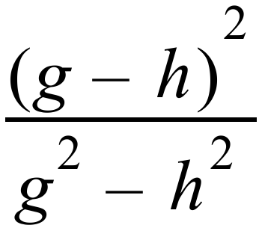

R12 (5 points) (40 points remaining)
Simplify the expression 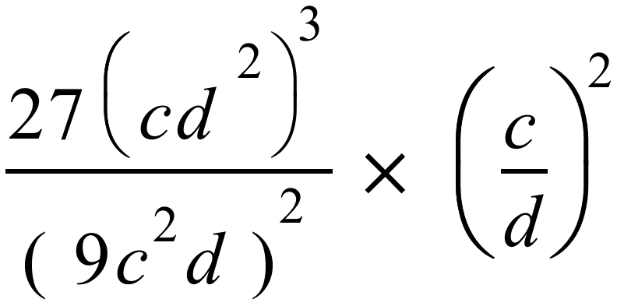
Your answer should consist of positive indices and whole numbers.

R13 (5 points) (35 points remaining)

A circular garden has radius 12 metres. A concrete path of uniform width surrounds the
garden. The area of the concrete surface is 141.57 m². To the nearest centimetre, what is the
width of the path?

R14 (5 points) (30 points remaining)
The escalator in a building makes an angle of 23° to the horizontal. If the top of the escalator
is 7.2m above the floor at the bottom of the escalator, and it takes 22 seconds for the journey
from top to bottom, what is the average speed in m/sec of the people standing on the escalator
as it moves them down? Round your answer to two decimal places.

R15 (5 points) (25 points remaining)
RST is a triangle in which RS = RT, and angle SRT is 36°. U and V are points on RT and RS
respectively so that SU = ST, and UV is perpendicular to RS. Find the size of angle SUV.

R16 (5 points) (20 points remaining)

On the Gatton Bypass along the Warrego Highway there is a 5-kilometre stretch
designated as an opportunity for drivers to check the accuracy of their cars’ speedometers.
Recently I set my car’s cruise control so that it read a constant 90km/hr as I drove along that
5-kilometres stretch. A passenger carefully measured the time taken for the car to travel the
distance of 5km and found that it was 3 minutes and 24 seconds.
Rounded to one decimal place, what was the true speed of the car in km/hr during the test?

R17 (5 points) (15 points remaining)
ABCD is a rectangle with AB = 7 units and BC = 24 units. Find the shortest distance from B
to the line AC.

R18 (5 points) (10 points remaining)
A parade is formed with 1980 soldiers standing equal distances apart in rows and columns, so
that the parade is as close to square as possible. How many soldiers are standing around the
outside?

R19 (5 points) (5 points remaining)

Find two solutions to this equation:- 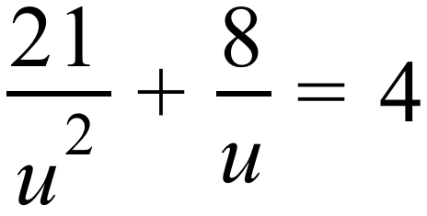

R20 (5 points) (0 points remaining)
A famer bought diesel fuel at $1.85 per litre, and unleaded fuel at $1.75 per litre. His total
bill was $267 for a total of 148L of fuel. How many litres of unleaded fuel did he purchase?

INTERMEDIATE SECONDARY MATHS TEAM CHALLENGE (2025)
Relay Answer Sheet (year 9 & 10)
Problem | Answer | Attempts √ or × 5 4 3 2 1 |  |  |  |  | Score | Progressive Score
R 1 (5 points) | 64
R 2 (5 points) | 325
R 3 (5 points) | 12
R 4 (5 points) | 48
Change Change
R 5 (5 points) | 20mm
R 6 (5 points) | 140$°$
R 7 (5 points) | 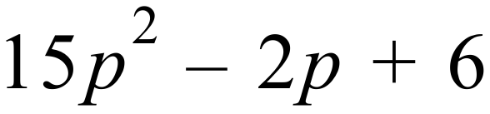
R 8 (5 points) | 4.4%
Change Change Change
R 9 (5 points) | D
R 10 (5points) | (6,-2)
R 11 (5 points) | 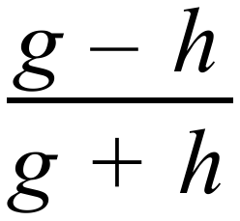
R 12 (5 points) | 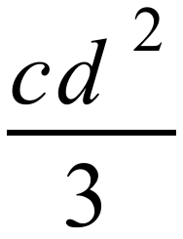
Change Change Change
R 13 (5 points) | 1.75m or 175cm
R 14 (5 points) | 0.84m/sec
R 15 (5 points) | 54°
R 16 (5 points) | 88.2km/hr
Change Change Change
R 17 (5 points) | 6.72 units
R 18 (5 points) | 174
R 19 (5 points) | 3.5 and −1.5.
R 20 (5 points) | 68L
Total

