2025 MATHEMATICS TEAM CHALLENGE
Junior Relay (year 7 & 8)

Time: 60 mins Calculators Allowed 100 points
-----------------------------------------------------------------------------------------------------------------------------------

R1. (4 points) [96 points remaining]
Taylor Swift’s Eras Tour involved 149 concerts in 51 cities. What is the least number of concerts that Taylor would need to have performed, to ensure that she conducted 3 concerts in at least one city?

R2. (4 points) [92 points remaining]
It is known that x and y are positive whole numbers and that $x+y=10.$ What is the largest possible value of the expression $\frac{1}{x}+ \frac{1}{y}$?

R3. (6 points) [86 points remaining]
Determine the sum of the first ten odd positive 2-digit integers that have a remainder of 1 when divided by 3.

R4. (2 points) [84 points remaining]
Two positive numbers are chosen at random. What is the probability that their product is even? Express your answer as a percent.

R5. (4 points) [80 points remaining]
The numbers 1, 3, 6, 10, 15,……are known as the triangular numbers. What is the largest triangular number less than 600?

R6. (8 points) [72 points remaining]
Two six sided fair dice are rolled. What is the probability that the product of the of the two outcomes is a prime number?

R7. (4 points) [68 points remaining]
Find the sum:

$${ 20}^{2}-{19}^{2}+{18}^{2}-{17}^{2}+…..+ 2^{2}-1^{2}$$

R8. (8 points) [60 points remaining]
What is the value of the sum below?

$$1-2+3-4+5-6+……-2022+2023-2024+2025$$

R9. (6 points) [54 points remaining]
In a vote for school captain, Caitlin received 60% of the votes and got 25 votes more then Emily. How many students voted?

R10. (4 points) [50 points remaining]
A cube has an edge of 3 cm. The cube is painted blue all over and then cut into 27 cubes of edge length 1 cm. How many of these cubes have no faces painted blue?

R11. (6 points) [44 points remaining]
What is the area of the triangle formed by the coordinate axes and the line through the points (0, 4) and (3, 0)?

R12. (6 points) [38 points remaining]
The sum of the ages of a man and his wife is 49 years. How old is the wife if the man is now twice as old as his wife was when he was the age that she is now?

R13. (6 points) [32 points remaining]
The first 6 hexagonal numbers are:

1, 6, 15, 28,45, 66, ……
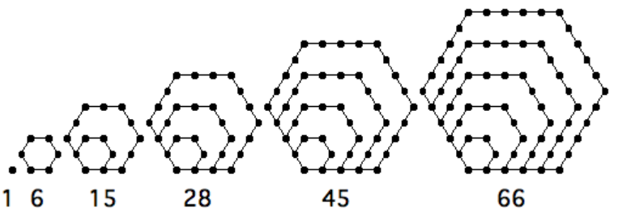

What is the 7th hexagonal number?

R14. (8 points) [24 points remaining]
Oranges in a fruit shop are stacked in a pyramid. 1 orange is in the top layer, 4 are in the second layer (from the top), 9 in the third layer, and 16 in the fourth layer, etc. How many layers high would a stack of 5525 oranges be?
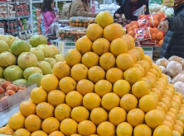

R15. (2 points) [22 points remaining]
What are the last two digits of the expression below when fully expanded?

$$5^{2025}$$

R16. (4 points) [18 points remaining]
The sum of the digits of a two-digit number is 17. When the digits are reversed, the number is reduced by 9. What is the number?

R17. (4 points) [14 points remaining]
Express N as an improper fraction.

$$N=1+ \frac{1}{2+\frac{1}{3}}$$

R18. (4 points) [10 points remaining]
The area of a regular hexagon is 10cm². What will the area be if the diagonals of the regular hexagon are doubled?

R19. (6 points) [4 points remaining]
The points A, B, C, D and E are located on a straight line in order.
- The distance between A and E is 40cm.
- The distance between A and D is 30 cm.
- The distance between B and E is 20 cm.
- C is halfway between B and D.
What is the distance between B and C?

R20. (4 points) [0 points remaining]
X and Y are the midpoints of the sides of a square. What fraction of the square is shaded?

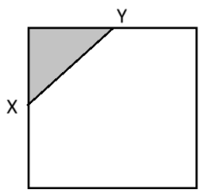

MATHS TEAM CHALLENGE (2025)
Relay Answer Sheet
Junior (yr 7 & 8)
Problem | Answer | Attempts √ or ×  8 7 6 5 4 3 2 1 |  |  |  |  |  |  |  | Score | Progressive Score
R 1 (4 points) | 103
R 2 (4 points) | $$\frac{10}{9}$$
R 3 (6 points) | 235
R 4 (2 points) | $\frac{3}{4} or$75%
Change Change Change
R 5 (4 points) | 595
R 6 (8 points) | $\frac{1}{6}$ or 16.67%
R 7 (4 points) | 210
R 8 (8 points) | 1013
Change Change Change
R 9 (6 points) | 125
R 10 (4 points) | 1
R 11 (6 points) | 6 unit²
R 12 (6 points) | 21 years
Change Change Change
R 13 (6 points) | 91
R 14 (8 points) | 25
R 15 (2 points) | 25
R 16 (4 points) | 98
Change Change Change
R 17 (4 points) | $$\frac{10}{7}$$
R 18 (4 points) | 40cm²
R 19 (6 points) | 5 cm
R 20 (4 points) | $$\frac{1}{8}$$
Total

School:___________________________________

Team 1: Team 2:

