2025 MATHEMATICS TEAM CHALLENGE
SENIOR SECONDARY
RELAY CONTEST

Time: 1 hour
Calculators may be used
Each question is worth 5 points
Total of 100 points

R1 (5 points) (95 points remaining)
What is the next term in the following sequence?

1, 8, 81, 1024, _____

R2 (5 points) (90 points remaining)
A 30 cm by 30 cm dartboard has nine congruent circles that are mutually tangent to each other and to the square. Suppose a dart always hits the board, what is the probability that it lands in a circle? (Express your answer as a percent accurate to 2 decimal places)

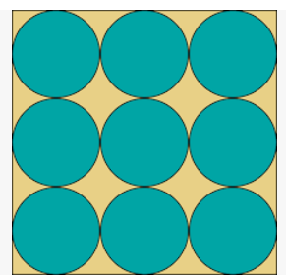

R3 (5 points) (85 points remaining)
What is the length of the shortest path that can connect the 16 dots below? The vertical and horizontal distance between any two adjacent dots is 1 metre.



R4 (5 points) (80 points remaining)
How many 4-digit numbers with all digits non-zero and no digits repeated are divisible by 25?

R5 (5 points) (75 points remaining)
What is the last digit X of the 9-digit number $28700028X,$ given that the number is prime?
R6 (5 points) (70 points remaining)
What is the value of the following expression?

$$\frac{tan⁡(10°)∙cos⁡(30°)∙cos⁡(90°)}{cos⁡(0°)∙tan⁡(30°)∙cos⁡(60°)∙tan⁡(60°)}$$

R7 (5 points) (65 points remaining)
The equations of the lines $2x+ay=11$ and $3x-5y+4=0$ intersect at right angles. Find the value of $a.$

R8 (5 points) (60 points remaining)
What is the exact value of the following infinite expression?

$\sqrt{6+\sqrt{6+\sqrt{6+……}}}$

R9 (5 points) (55 points remaining)
Queen’s Park has a square patch of grass measuring 100 m $×$ 100 m. The council wants to construct a diagonal sidewalk that is 2 metres wide and 12 centimetres deep. How many cubic metres of cement would be required? (Round to the nearest whole cubic metre)

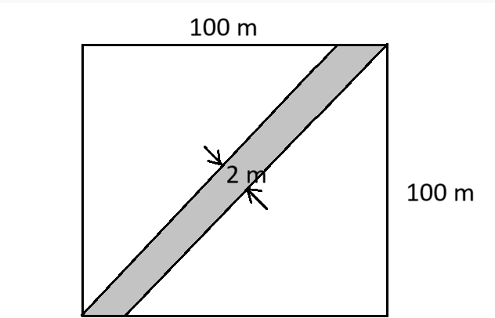

R10 (5 points) (50 points remaining)
A 6-sided die is labelled with the first 6 prime numbers instead of the integers 1 to 6. The die is rolled twice. What is the probability that the sum of the rolls is a square number?

R11 (5 points) (45 points remaining)
Joseph Lagrange was an eighteenth-century mathematician who proved that every integer is the sum of, at most four squares. Find one way to write 91 as the sum of four different squares.

R12 (5 points) (40 points remaining)
The average daily high temperature in Toowoomba for the first 20 days of January 2020, was $27.8°$C. What must the average daily high temperature have been for the remainder of the month if the overall January 2020 average daily high temperature was $30°$ C?
(Round to the nearest whole $°$ C)

R13 (5 points) (35 points remaining)

The 2 x 2 grid below is worth 9 points and the 1 x 1 grid is worth 4 points.
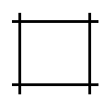

= 4 points
= 9 points

How many points is a 10 $×$ 10 grid worth?

R14 (5 points) (30 points remaining)
If ${16}^{4}×{64}^{8}= {256}^{x}$, what is the value of $x$?

R15 (5 points) (25 points remaining)
What is the area of the largest regular octagon that can be inscribed in a square with side length 1 metre? (Answer to two decimal places)

R16 (5 points) (20 points remaining)
Determine the value of $(x, y)$ that satisfies the simultaneous equations below.

$$5x+7y=9$$
$$12x+16y=20$$
R17 (5 points) (15 points remaining)
The product of three numbers in a geometric progression is 1000.
The sum of the three numbers is 39. What is the largest of the three numbers?

R18 (5 points) (10 points remaining)
Given $x$ and $y$ are two real numbers such that $x-y=3$ and $x^{2}+ y^{2}$ = 10. Find $x^{3}-y^{3}.$

R19 (5 points) (5 points remaining
A two-digit number AN (where A stands for the tens digit and N stands for the ones digit), is squared and results in the 3-digit number TAN. What is the value of AN?

R20 (5 points) (0 points remaining)
Express the integer 25 in base 2. (For example, 13 in base 2 = 1101)

SENIOR SECONDARY MATHS TEAM CHALLENGE (2025)
Relay Answer Sheet
Problem | Answer | Attempts √ or × 5 4 3 2 1 |  |  |  |  | Score | Progressive Score
R 1 (5 points) | 15625
R 2 (5 points) | 78.54%
R 3 (5 points) | 15 m
R 4 (5 points) | 84
Change Change
R 5 (5 points) | 1
R 6 (5 points) | 0
R 7 (5 points) | a = $\frac{6}{5}$ or 1.2
R 8 (5 points) | 3
Change Change
R 9 (5 points) | 34 m³
R 10 (5 points) | $\frac{7}{36}$ or 0.1944 or 19.44%
R 11 (5 points) | 1 + 16 + 25 + 49 = 91
R 12 (5 points) | 34$°$C
Change Change
R 13 (5 points) | 121
R 14 (5 points) | x = 8
R 15 (5 points) | 0.83m²
R 16 (5 points) | (x, y) = (-1, 2)
Change Change
R 17 (5 points) | 25
R 18 (5 points) | $\frac{63}{2}$ or 31.5
R 19 (5 points) | 25
R 20 (5 points) | 11001
Total

School:___________________________________

Team 1: Team 2:

